**This tutorial will show you how to install the Arduino IDE on Windows**

**Step 1: Go to the Arduino.cc Website**

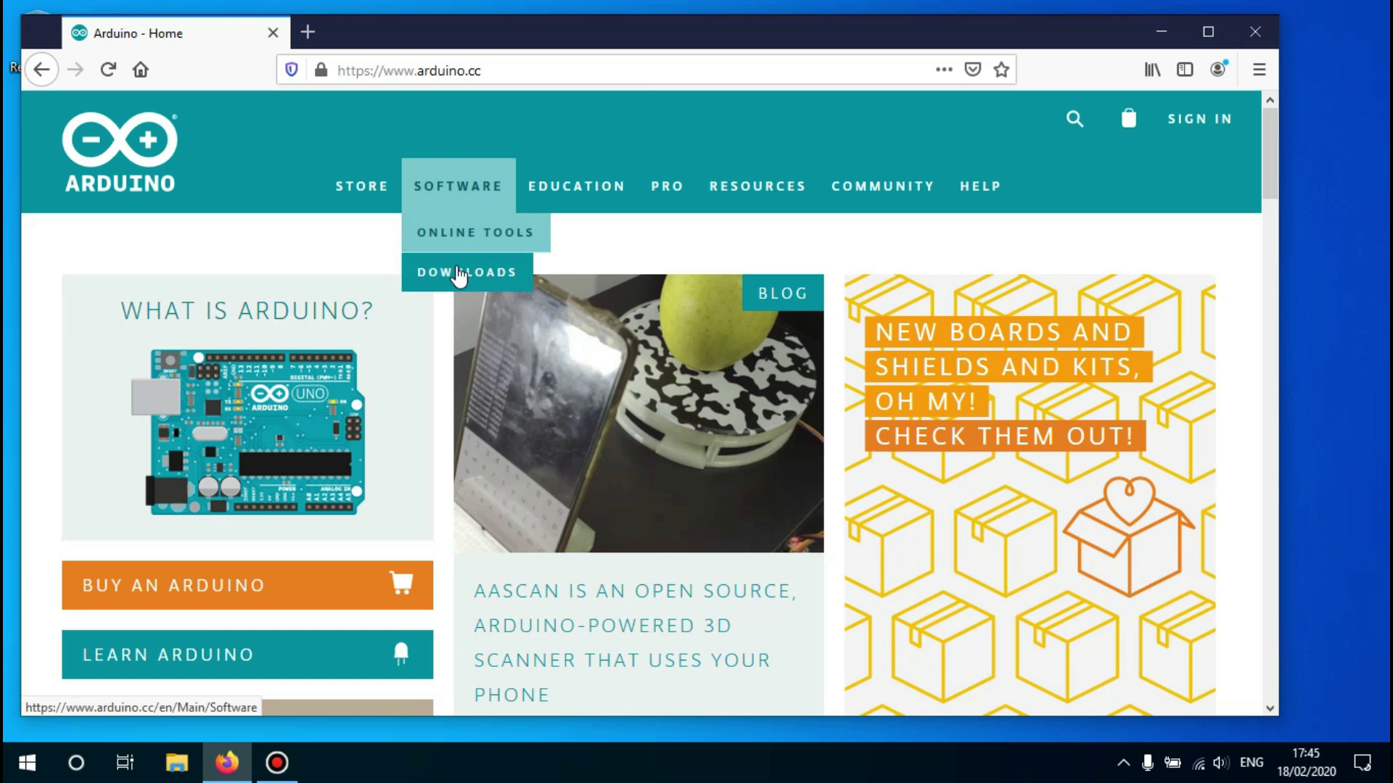

Hover over the 'Software' tab and click on 'Downloads'.

## **Step 2: Click on the Download Link**

Scroll down until you see the version 1.8.19 ' and click on windows 7 or newer.

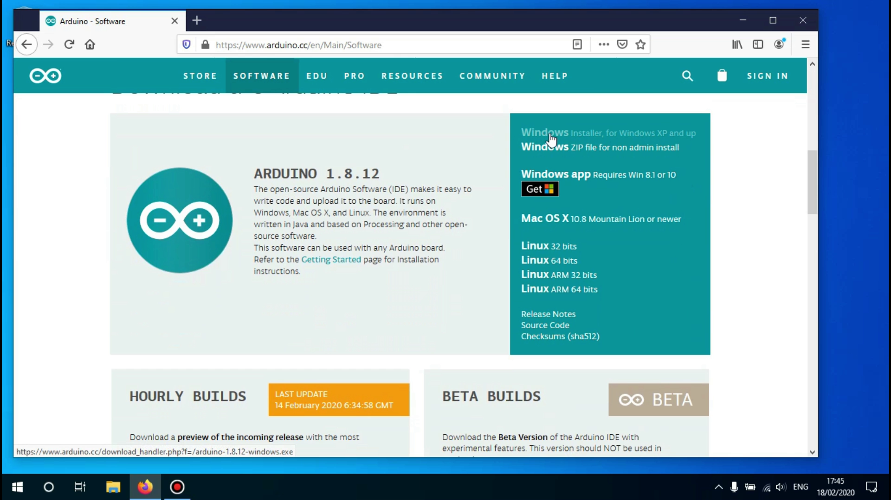

## 

## 

## 

## **Step 3: Begin the Download**

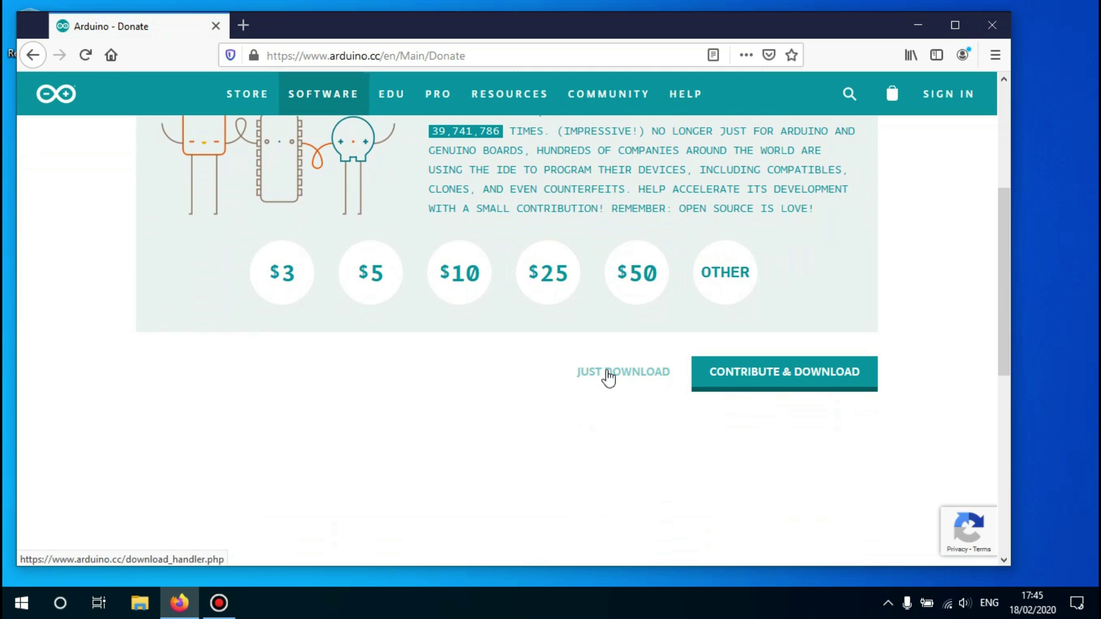

After clicking on the just download link you'll be redirected to the donation page, clicking on the 'Just download' link Again.

## **Step 4: Begin the Installation Process**

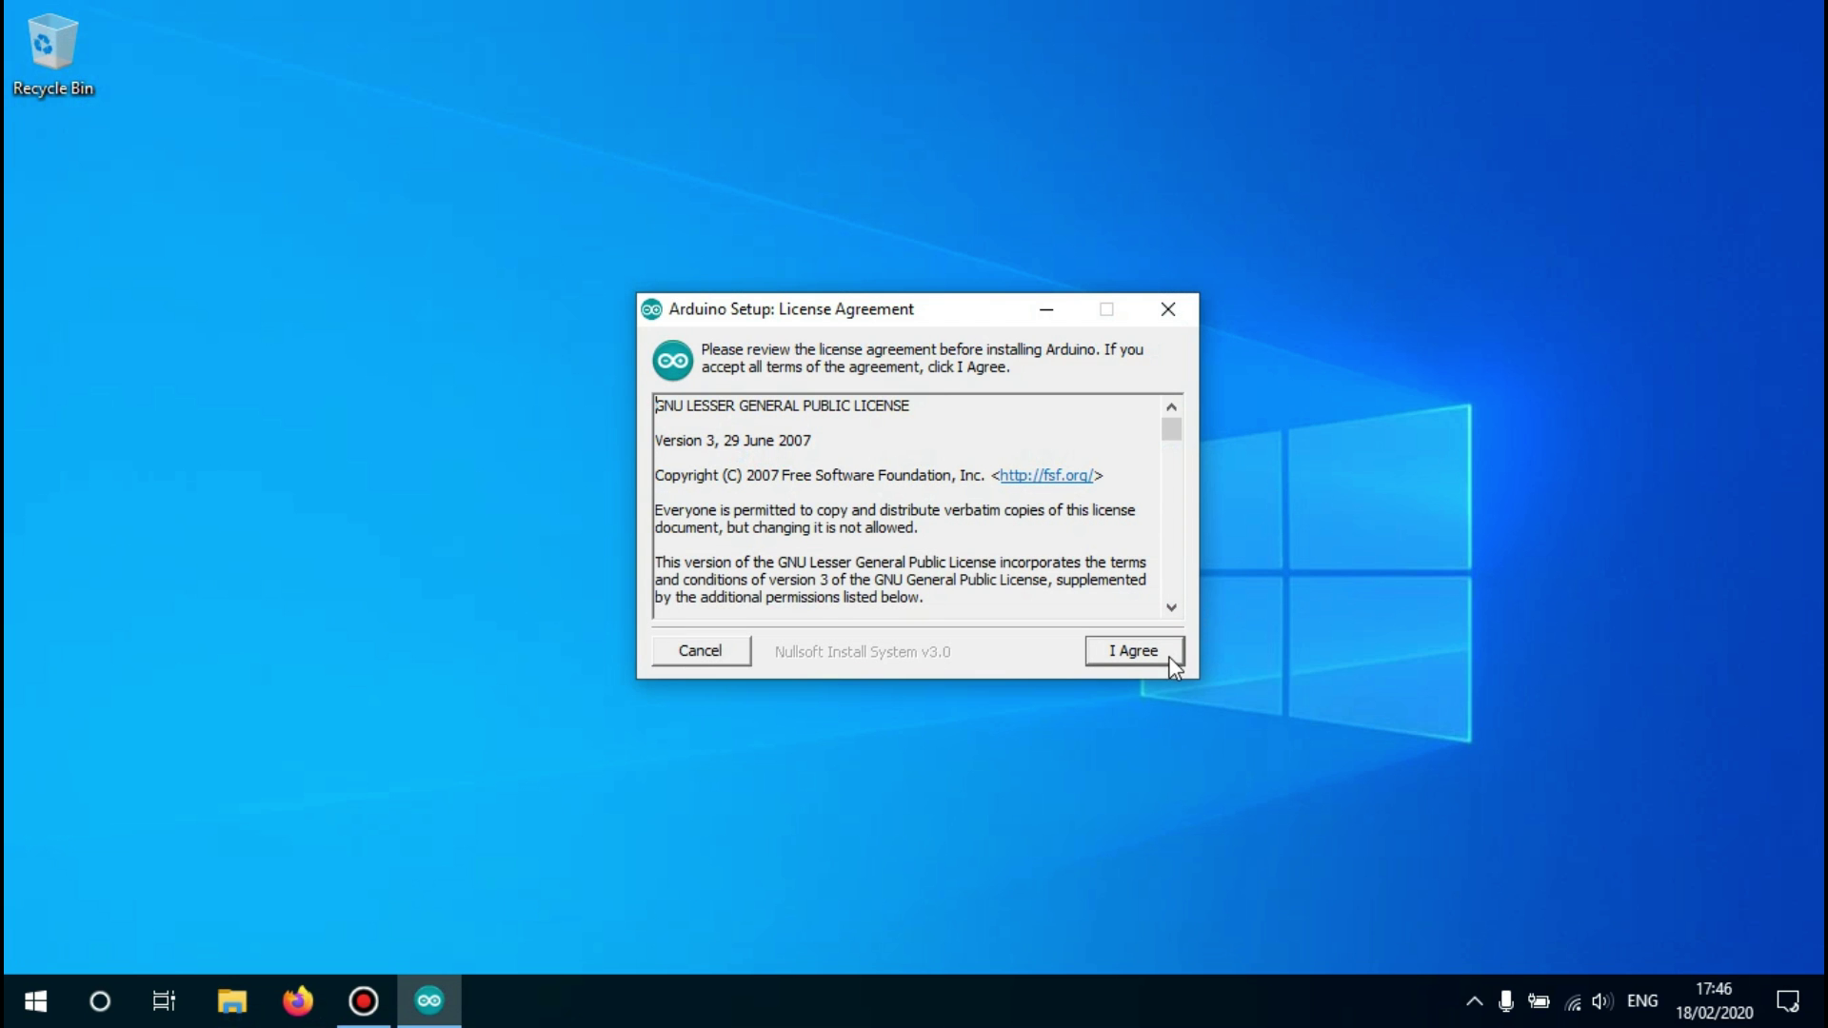

Open the downloaded file.A new window will open asking you to agree to the license agreement.Click on 'I agree' to continue.

## 

## 

## **Step 5: Select What to Install**

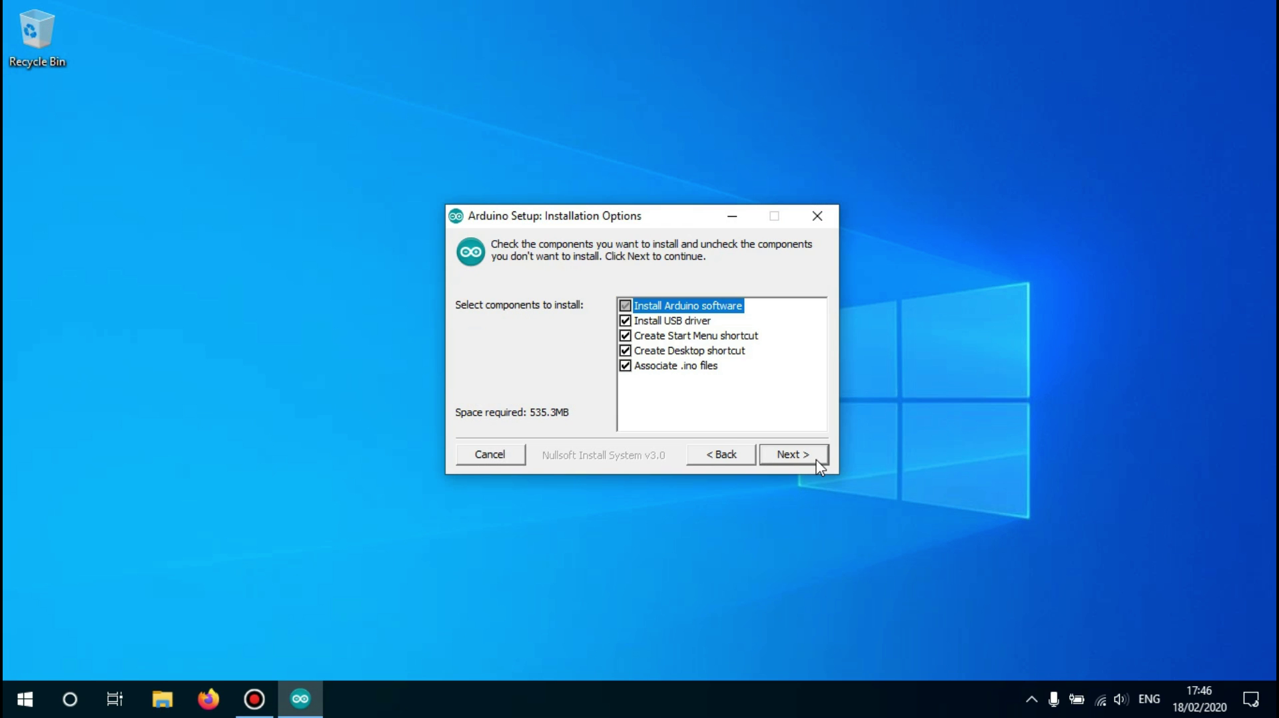

Now you'll see all the available options to install the software with.

If you don't know what you need, it is best to keep everything checked as you can change it later when the installation has finished.

Click on 'Next' to continue.

## **Step 6: Choose the Installation Path**

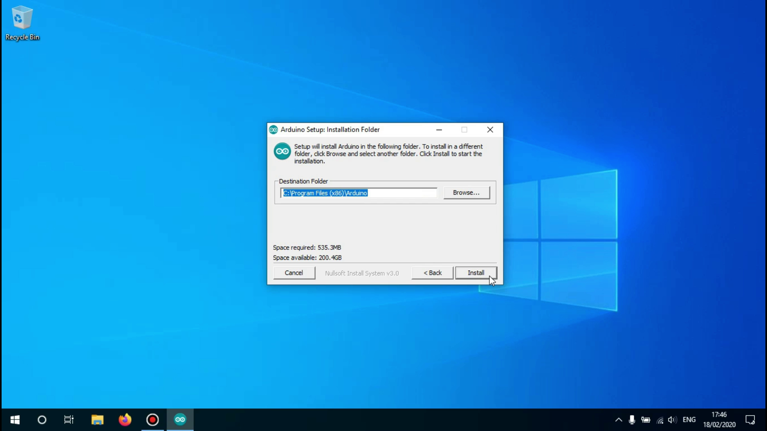

Now you have to choose the path the software will be installed in.it is fine to leave it at the configured location but if you want the Arduino IDE somewhere else installed you can change that here.Click on 'Install' to begin the installation

## 

## **Step 7:drivers installation**

It pops up for 3 times the dialog box to install the drivers. Click on install for 3 time .

## 

## **Step 8: Finish the Installation**

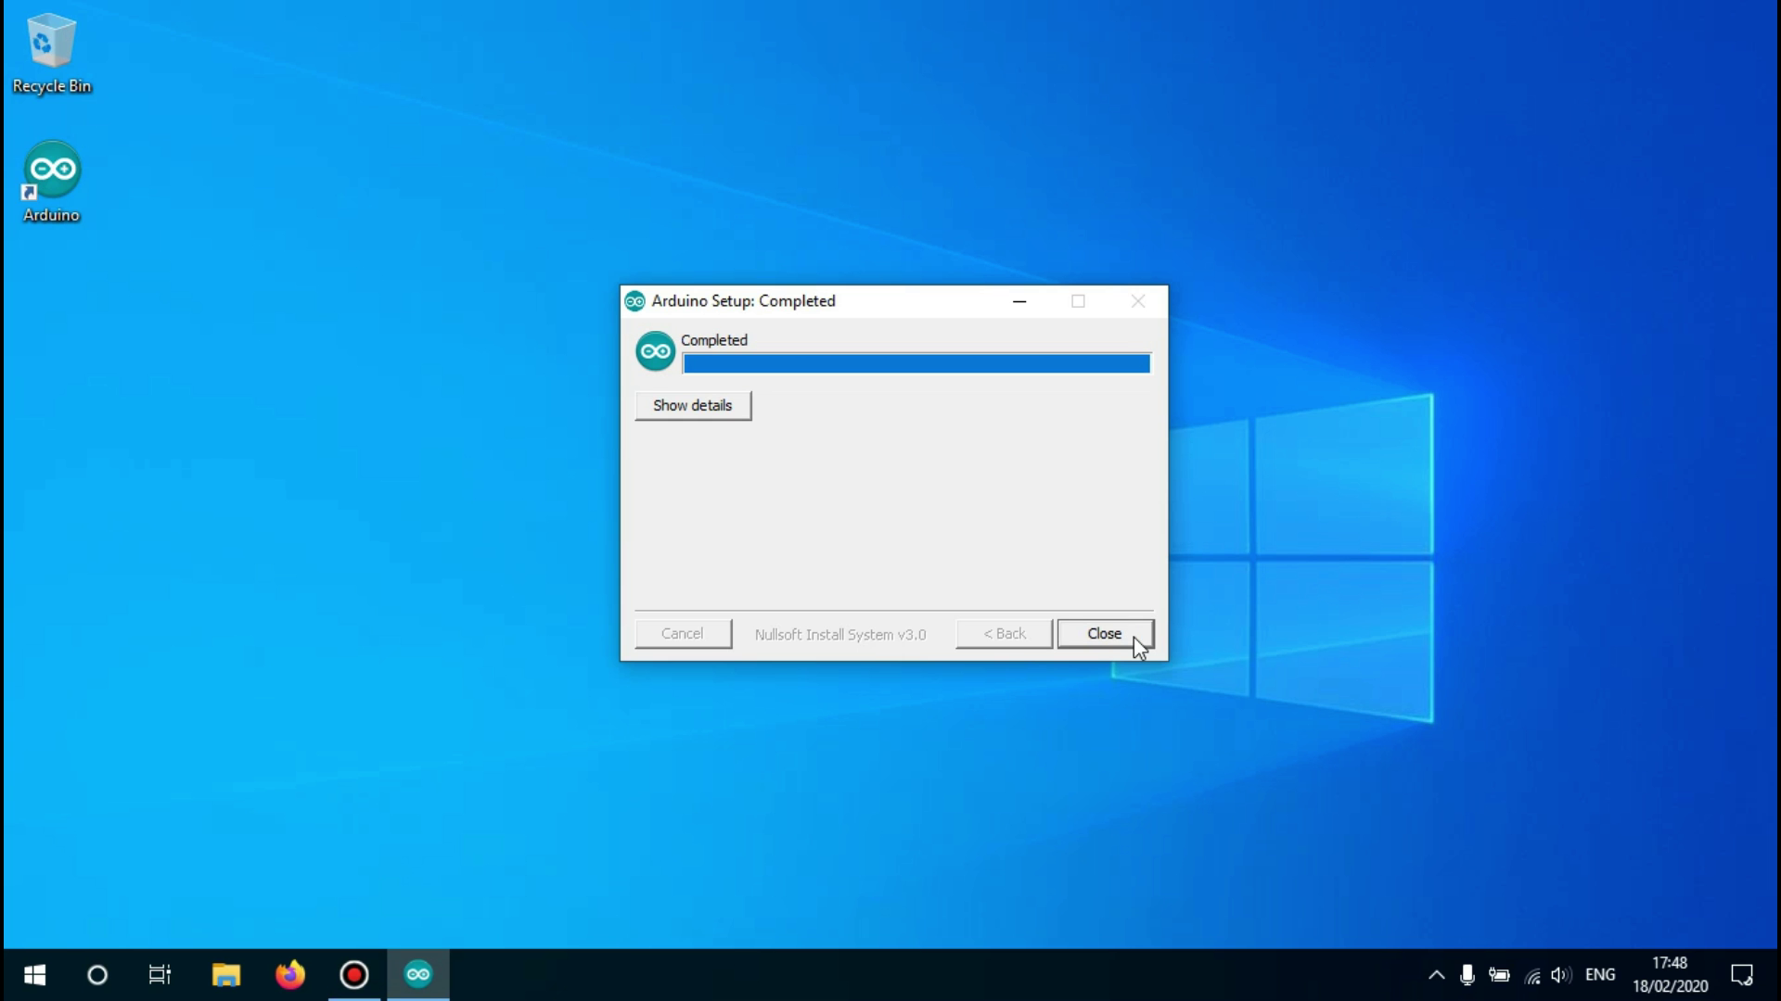

Wait until the installation is finished, it shouldn't take very long.

When the installation is finished you may click on 'close' .

## **Step 9: Launch the Arduino IDE**

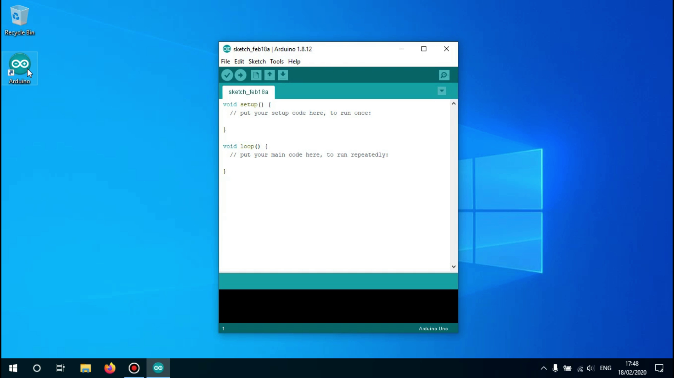

The Arduino IDE has now been successfully installed.

## **Install ESP8266 Add-on in Arduino IDE**

To install the ESP8266 board in your Arduino IDE, follow these next instructions

Step1: In your Arduino IDE, go to **File**> **Preferences**

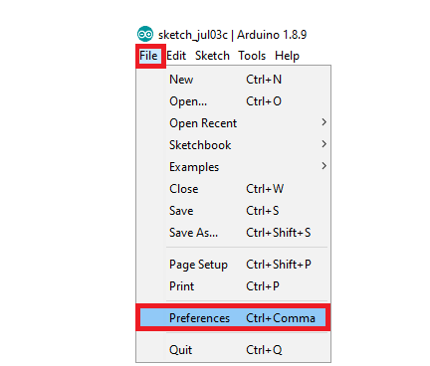

Step2:”[**http://arduino.esp8266.com/stable/package_esp8266com_index.json**](http://arduino.esp8266.com/stable/package_esp8266com_index.json)**”**

copy this link and paste then click on ok.

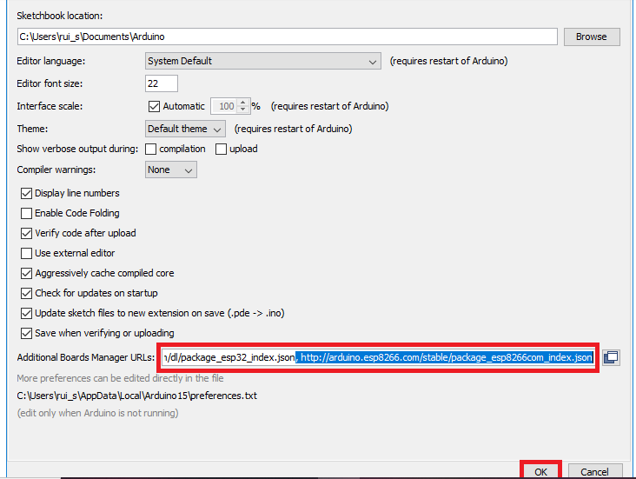

**step3:Open the Boards Manager. Go to Tools > Board > Boards Manager.**

**Step4: Search for ESP8266 and press install button for the “ESP8266 by ESP8266 Community“:**

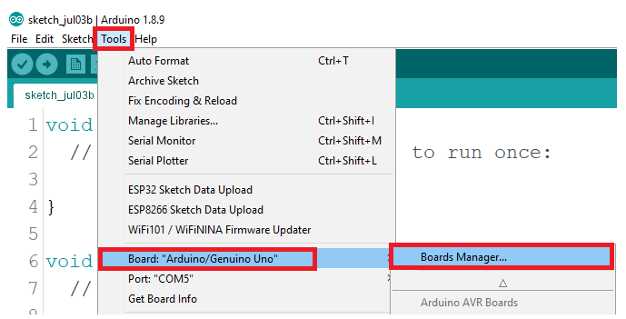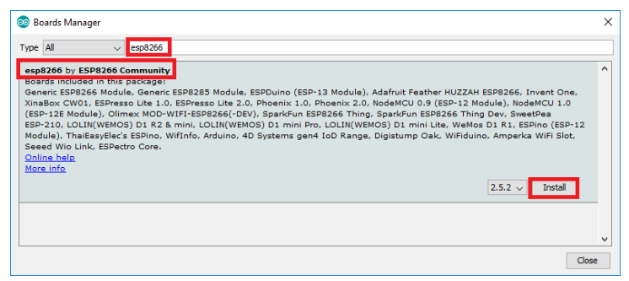

**That’s it. It should be installed after a few seconds.**

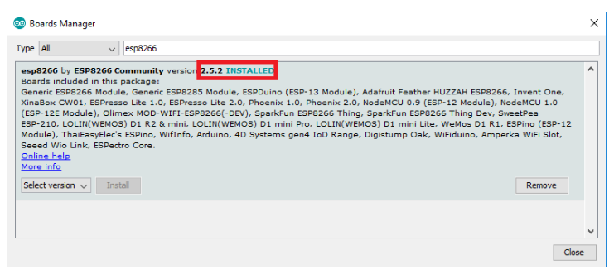

**Drivers Installation**